**You tube Subtitle Generation(Speech to Text) issues**

**1.** Understanding an accent or word that you speak quickly and when that word you spoke becomes similar to another words e.g in this video <https://www.youtube.com/watch?v=GazFsfcijXQ&feature=youtu.be>

on minutes 4:25 the Siraj says “Lemmatization”, but the You tube Speech to Text generate a text like “Limitation”

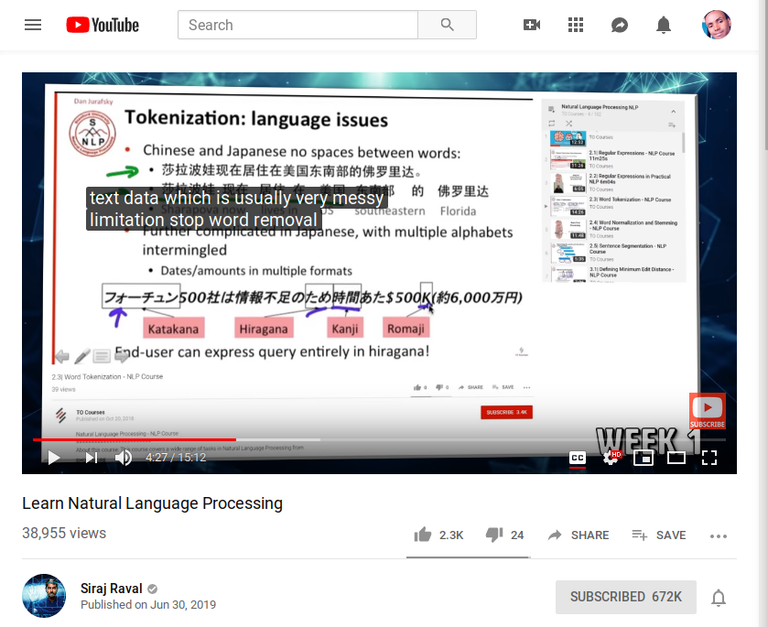

also in minutes 6:57 “whole documents” as “hold documents”. So this can lead to wrong meanings.

**2.**  Misunderstanding word that it did not know before how it was written. e.g for the same previous video when the Siraj says **Pytorch**, but the Youtube Subtitle Generation, write this one as **PI Torch.**

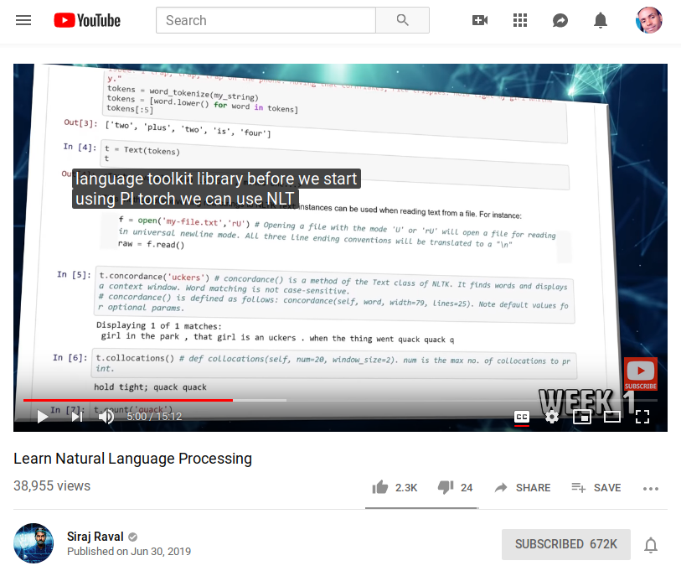

Also it recognize Pytorch some times as “High Torch” check from minutes 12:27

**3.** The big issues of Text Generation of Subtitle Generation of Youtube is that it Can Not Provide **Punctuation Marks**. e.g it does not know that its end of the sentence then provide full stop(point). Or that its a list and provide commas, or that its a question and provide question mark ? Just like this. What it does is just connect all the words together without any separation as they are one sentences. And I think this is may be difficult for the person understand if he/she provided only the generated texts without the speechs.